1. **Proposed Title**

Software-defined Camera for Outdoor Surveillance Applications

1. **How would you categorize this project? [Tick only ONE]**
   1. An effort to facilitate an existing Research/ Industry Project
   2. **An effort to facilitate developing a Research/ Industry Funded Proposal for possible Funding**
   3. An effort to facilitate Master’s/ PhD project objectives
   4. An exploratory study
   5. An experimental study for better lab utilization/ development
   6. A capstone project for students allowing them to apply their learning
   7. Other (please specify):
2. **What characteristics of the Complex Engineering Problem (CEP) are applicable to this project? [Tick one or more, if applicable]**
   1. **Range of conflicting requirements: technical, engineering or other issues**
   2. Depth of analysis required: have no obvious solution and require abstract thinking
   3. **Depth of knowledge required: require research-based knowledge**
   4. Familiarity of issues: Involve infrequently encountered issues
   5. Extent of applicable codes: standards and codes devised by the professional bodies
   6. Extent of stakeholder involvement and level of conflicting requirements
   7. Consequences: Impact over the society
   8. Interdependence: problems due to dependability
3. **Brief Outline**

# Image processing applications are widely used nowadays which need to analyze and process a large number of images and video streams in real-time. This real-time constraint can be handled if the live camera feed is preprocessed right at the edge device i.e. an FPGA. The FPGA coupled with an image sensor is used to develop a camera that is adaptive and can preprocess the incoming live camera feed using high-level synthesis. Thus, this approach proposes to define a Software-Defined Camera that utilizes the software-hardware co-design functionality of the Zynq-7000 FPGA.

1. **Objectives**

# • To study and determine exact parameters which can be manipulated to produce high quality images.

# • To integrate different models of the environment for an efficient solution.

# • To exploit the internal architecture of the image sensor.

# • To develop image pre-processing IP cores and implement a solution that will integrate all the cores.

# • To test the software-defined camera for outdoor surveillance applications under various environmental

# conditions.

1. **Scope**

# All the computer vision algorithms that perform image analysis and processing require high quality images. The conventional cameras are not programmable; hence can’t provide a constant and standard image quality in different scenarios. Also, all real time applications need to process data as fast as possible; the images need to be pre-processed as well before they can be used to generate useful results according to the requirements of an application. If the environment diverges from normal, more computationally intensive & time-consuming algorithms will be required to generate clean and clear images before using them in computer vision applications.

# This forwards us towards software-defined camera; where imaging sensor inside camera is adaptive to respond environment. Therefore, processing the images directly on the camera, taking advantage of the sensors to become environmentally conscious. Such a camera takes over the load of preprocessing images. The strategy is to make camera smart enough so that it can sense its surroundings and noise, adjusts its internal hardware and select most suitable parameters for the situation even before the image is captured. In this way, the quality of image will be constant. However, in a practical scenario, some of the images might be affected but there would not be in depth data loss hence data recovery will be possible.

1. **Methodology**

# Our project’s aim is to make camera smart enough, such that it produces high quality images in varying

# environment. The methodology we will use to achieve our target comprise of:

# Environmental Profiling:

# Conventional cameras will be used for capturing images in different environments at regular intervals. These images help in determining the most varying parameters.

# Image Sensor Integration:

# PCAM 5C module will be connected to the FPGA board and a set of open-source Vivado IP cores will be used for its configuration in software.

# Image Processing Cores using Vivado HLS:

# Vivado High Level Synthesis will be used for generation of different soft IP cores.

1. **Expected Outcomes of the proposed project**

A remotely deployable software-defined camera solution that can adjust to different conditions, producing high-quality output video stream with minimal processing time, thus lessening the load of image pre-processing on server-side applications.

|  |  |  |  |
| --- | --- | --- | --- |
| **No.** | **Elapsed time (in months) from start of the project** | **Milestone** | **Deliverables** |
| 1. | 1 month | Literature review | Proposal |
| 2. | 2 months | Learning Verilog | Implementation of different combinational and sequential circuits |
| 3. | 2.5 month | Testing Image Sensor Registers | A document containing camera registers that are to be manipulated . |
| 4. | 3.5 month | Vivado design suite | RTL synthesis and simulation of designed modules |
| 5. | 4 months | Xilinx SDK |  |
| 6. | 4.5 month | Vivado HLS |  |
| 7. | 5.5 month | Explore Hardware | Implementation of earlier developed modules on fpga |
| 8. | 6 months | Teraterm |  |
| 9. | 6.5 month | Image Sensor Integration | Prototype |
| 10. | 8 months | IP cores designing | Focus on making different camera features adaptive(brightness, hue, saturation, contrast etc) |
| 11. | 9 months | Application testing | Fully tested Software Defined Camera |
| 12. | 10 months | Documentation | Report and Research paper |

1. **Expected Budget**
2. **Attach Gantt Chart for the Project Work**

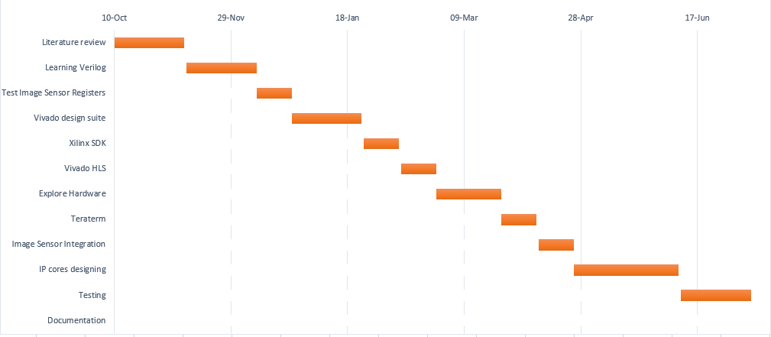

1. **Alignment of project with departmental/programme mission and SDGs*.***

The mission of Computer Systems Engineering program is “to impart world-class education to computer engineers, enabling them to exhibit outstanding professional skills, practice ethics of highest standards and impact society transformations through technological innovations.”

Our project contributes in society transformation through technological innovations as traditional cameras used in image processing applications are inflexible and unaware of their environment, therefore requires server-side computational extensive as well as cost expensive algorithms for image enhancement and quality amplification tasks. Our project aims to make an adaptive camera, a camera that is programmable, a camera that can sense the lessening of environment and apply preprocessing before capturing, right on the edge device (FPGA), to provide standard quality images in a varying environment without using server-side algorithms.

Our project aligns with SDG Goal 9: **Industry, Innovation and Infrastructure.** There are a number of industries build around computer vision applications and our project’s aim is to provide ease in getting the standard quality image data in a varying environment. Thus, it can serve as an innovation for these industries.

Name of Supervisor: **FAKHRA AFTAB**

Signature: ______________

Name of Co-Supervisor (if any): **Dr. MAJIDA KAZMI**

Signature: ________________

Name of Industrial Advisor (if any):

**Recommendations and Approval:**

**Chairperson (Head of FYDP Review Committee) Sign with Date:**